MED D - Request to Change Enrollment Effective Date

General Information
Effective Date Change
Related Documents

Description: This document provides the CCR with information on how to handle a beneficiary or legal representative’s request to change the effective date of enrollment.

General Information
The Effective Date of Enrollment is the date that a beneficiary can utilize their benefits. This date is determined by the enrollment period use on the application and when application was submitted.
In the most scenarios, a beneficiary is not able to change their benefit effective date. This date is determined by the date the application, as received by the plan sponsor and the enrollment period used for the application.
There are three types of enrollment/election periods that a beneficiary can use to enroll in a MED D Prescription Drug Plan or Medicare Advantage Prescription Drug Plan (MAPD):
- Initial Enrollment Period
- Annual Enrollment Period
- Special Enrollment Period
However, there may be exceptions where a beneficiary can change their effective date. The most common scenarios are:
- Beneficiary is eligible for two different election/enrollment periods
- Beneficiary is enrolling into Employer/Union Group Health Plan (EGHP)
- Beneficiary is eligible for an SEP due to Involuntary Loss of Creditable Coverage
Possible effective date change scenarios are not limited to the above. For further information on the effective date of enrollment and election periods. Refer to MED D - Election Periods for Enrollment and Disenrollment (AEP, IEP, SEP).

Top of the Document

Effective Date Change

Access to MARx and FAZAL may be required to research and complete an effective date change.

Perform the following:
Step | Action
1 | Access the beneficiary’s account through the Medicare D Inquiry Tab in PeopleSafe. Review the Benefit Effective date and provide that date to the beneficiary.  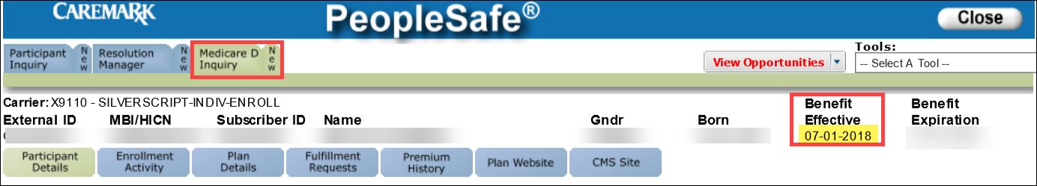  Does the beneficiary want to request a change in their Benefit Effective date?  Note: Requests can only be submitted if prior to the Benefit Effective Date in PeopleSafe.
1 | If... | Then...
1 | Yes | Proceed to next step.
1 | No | Address any other issues.
2 | Confirm the following information with the caller:  - The effective date requested for the beneficiary  - The enrollment period/SEP used on the current application  - The reason the change for the requested change  - Cell phone number or readily accessible home phone number for the caller  Proceed to the next step.
3 | Access the Resolution Manager tab in PeopleSafe. Create a new task with the following:  - Category: Med D Enrollment – Enrollment  - Task Type: Effective Date Change  - Queue: Med D Enrollment  - Client Code: 9110 (or other Client Code)  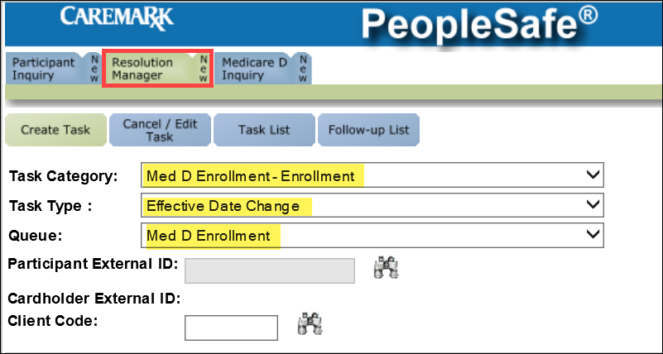  Proceed to next step.
4 | Complete the required fields in the Task Data section.  - Caller Name:  - Verbal Attestation: Yes  - Contract Type: Facilitated – SSI  - Earlier Effective Date:  - Contract ID: S5601  - PBP ID:  - MBI:  - Member ID:  - First Name, Middle Initial, and Last Name:  - Participant Area Code and Phone Number:  - Date of Birth:  - State:  Enter the following in the Notes section of the RM task using the following template.  <Caller> contacted the plan on <date> requesting an Effective Date Change for <beneficiary name>. The beneficiary is requesting this change because <why>. The beneficiary requests an effective date of <date>. The <beneficiary/POA/authorized representative> can be contacted at <phone number>.  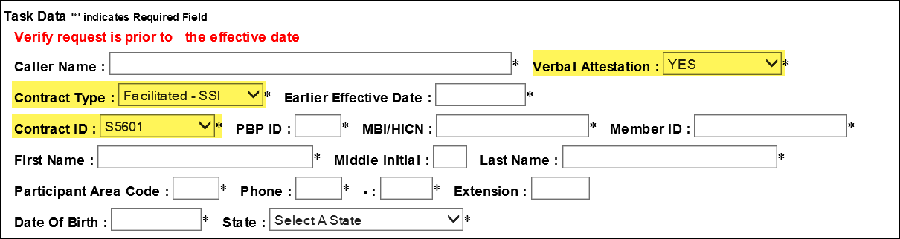  CCRs MUST obtain a valid phone number. Member Services needs to contact the beneficiary to confirm the required information. It is STRONGLY recommended that the beneficiary provide a cell phone number, if available.  Proceed to next step.
5 | I have submitted a request to our member services team to review the requested change. This team will contact you within 4 days to verify the information provided. Please be advised that if we are unable to confirm the information, your request will be denied.

Top of the Document

Related Documents
- Grievance Standard Verbiage (for use in Discussion with Beneficiary) section in MED D - Grievances Index
- MED D Enrollment - FAZAL
- MED D - SHIP Counselor Calls for CVS Caremark Part D Plans
- MED D - Appointed Representative Form (AOR) or Power of Attorney (POA)
- MED D - SilverScript and Blue MedicareRx (NEJE) - Enrollment Related RM Tasks
- MED D - Election Periods for Enrollment and Disenrollment (AEP, IEP, SEP)
- MED D - CMS Passive Enrollment in MMP - Required Voluntary Disenrollment from the PDP, Opt-Out and Disenrollment from the MMP

Parent SOP:
- MEDS-0041: Medicare Part D Voluntary Disenrollment, CVS Caremark Part D Services, L.L.C., Policy and Procedure
- MEDS-0006: Medicare Part D - Cancellation of Enrollment and Disenrollment Policy and Procedure, CVS Caremark Part D Services, L.L.C.
- CALL-0048: Medicare Part D - Customer Care Call Center Requirements, CVS Caremark Part D Services, L.L.C.
Abbreviations/Definitions:
- Abbreviations / Definitions

Top of the Document

Not To Be Reproduced Or Disclosed to Others Without Prior Written Approval
ELECTRONIC DATA = OFFICIAL VERSION – PAPER COPY = INFORMATIONAL ONLY

